|  |  |
| --- | --- |
| No. of Pages | **3**  B |
| No. of Questions | **3** |

**Department of Computer Science and Engineering**

**MIDTERM EXAMINATION SPRING 2018**

**CSE421: Computer Network**

**Total Marks: 45 Time Allowed: 50 minutes**



* Answer ALL **THREE (3)** questions
* Figure in bracket [] next to each question indicates marks for that question



**Question 1**

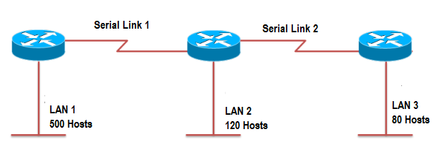

**Figure no. 1**

1. Suppose a company is given a network address **193.32.100.0/22.** Show how you can create required multiple subnets from the given single network address as shown in the above figure no.1, Do not forget to show basic calculations. [8 marks]

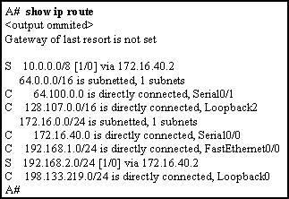

**Figure no. 2**

1. Refer to the routing table shown in figure no. 2 above. Packets destined to which two networks will require the router to perform a recursive lookup? [2 marks]
2. An administrator issues the command on a router. [2+3 marks]

**R1(config)# ipv6 route 2001:db8:acad:1::/32 gigabitethernet0/0 2001:db8:acad:6::1 8**

1. Why both the next hop IP address and exit interface are used in the static route command?
2. What is the number “8” and why is it assigned here?

|  |  |  |  |  |
| --- | --- | --- | --- | --- |
| **Node A Table** | | |  |  |
|  | **A** | **B** | **C** | **D** |
| A | 0 | 3 | 5 | 9 |

**Question 2**

|  |  |  |  |  |
| --- | --- | --- | --- | --- |
| **Node B Table** | | |  |  |
|  | **A** | **B** | **C** | **D** |
| B | 3 | 0 | **∞** | 4 |

|  |  |  |  |  |
| --- | --- | --- | --- | --- |
| **Node D Table** | | |  |  |
|  | **A** | **B** | **C** | **D** |
| D | 9 | 4 | 2 | 0 |

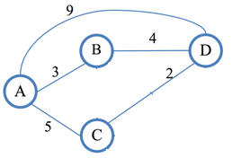

**Figure no. 3**

1. The tables represent the routing table of Router A, B and D at a single point of time. Router D receives updates from A and B routers. All routers are running Distance Vector algorithm. How will Router D calculate the best paths to all destinations after receiving the updates from A and B only? (Use Dx(y) = min{c(x,y) + Dy(y), c(x,z) + Dz(y)} for explaining your answer) [6 marks]

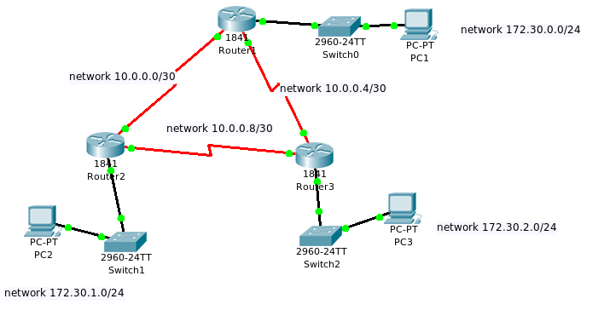

**Figure no. 4**

1. All routers the figure no.4 above is running RIPv2. Automatic summarization is turned on in all the routers. Users are complaining of packets being dropped. Why is this happening? [4 marks]
2. A router has a RIPv2 route to 100.18.20.0 in its routing table, with the metric 4 hops. It has not been receiving information regarding that route from its neighbour for 150 seconds, and then it receives an update from another router that it is 5 hops away, what will the router do? What if it receives no updates even after 180 seconds? [2+3 marks]

**Question 3**

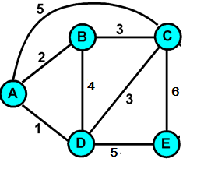

**Figure no. 5**

1. Link state routing protocol uses Dijkstra’s algorithm. Now using Dijkstra’s algorithm, compute the shortest path from Node **B** to all other remote networks shown in the figure no. 5. Use the table provided. [6 marks]

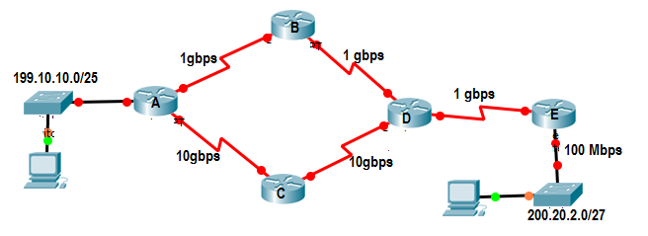

**Figure no. 6**

1. Refer to figure no.6, all routers are running OSPF routing protocol. The bandwidth has been changed in all routers to reflect the actual bandwidth of all the interfaces instead of the default bandwidth. Which path/s will Router A take to send packets to network 200.20.2.0/27 and why? And what is the cost of that path? [3+2 marks]
2. State two differences between Hello packets and Link State packets or Database Description packets in OSPF routing protocol? [4 marks]

**THE END**